Pokhara University

Level: Bachelor | Semester – Spring | Year : 2008
Programme: BE |  | Full Marks: 100
Course: Electronic Circuits I |  | Time : 3hrs.

Candidates are required to give their answers in their own words as far as practicable.
The figures in the margin indicate full marks.

Attempt all the questions.

 | - Draw two stage RC coupled amplifier. Derive the expression of total voltage gain for n-stage cascaded amplifier. Which configuration of BJT is used in intermediate stages while cascading and why?  - Find the voltage gin v_{l} / v_{s} for the amplifier as shown. Let β=100.  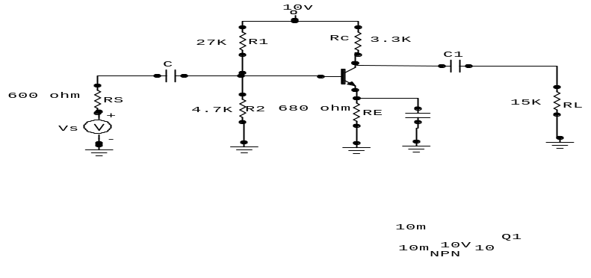 | 8  7
 | - Define distortion and describe different types of distortion that occurs in amplifier.  - Why Miller’s theorem is used to find upper cut off frequency for Common Emitter Self bias circuit? Explain.  - Classify power amplifier on the basis of conduction. | 5  5  5
 | - Explain different types of feedback topologies.  - What are the Barkhausen Criteria of oscillation? For RC Phase shift oscillator, the feedback ratio is given by  β = -1/( 1-5α²-j( 6 α- α³)).  Where α = 1/ ωRC.  Find the value of (i) frequency of oscillation (ii) The transfer gain of amplifier. | 7  8
 | - Explain the basic principle of voltage controlled oscillator (VCO) with block diagram.  - What are the main characteristics and features of op amp? Explain.  - Design an Operational amplifier circuit using two inverting configuration to produce output V_{O} = -10V₁+ 5V₂+ 0.5V₃ - 20V₄. | 5  5  5
 | - Define hysteresis and explain about Schmitt trigger.  - Find the successive approximation A/D output for a 4 bit converter to a 3.217 V input with reference voltage, V_{R}= 5V. | 7  8
 | - Draw half wave rectifier circuit and explain its operation. Compare its average voltage, rms voltage and ripple factor with full wave rectifier circuit.  - What is a regulated power supply? Calculate the output voltage and zener current in the regulator circuit as shown. Let V_{Z}=8.3V, β=100.  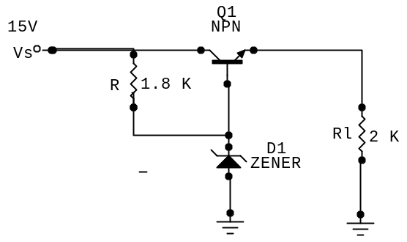 | 7  8
 | Write short notes on (Any Two):  - R-2R D/A converter.  - Cross Over Distortion and Class AB amplifier.  - Effect of negative feedback on bandwidth. | 2×5

